**The class Graph is the implementation of a graph.**

**Input.txt**

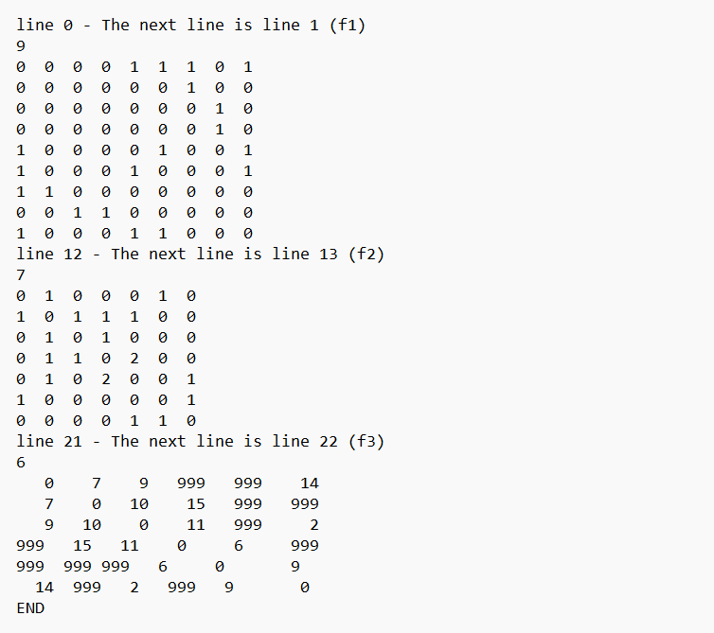

**Q3.1**

**Perfom depth-first traversal (to the file f1.xt) from the vertex i=1 (the vertex B) but display vertices with their deegrees in bracket.**

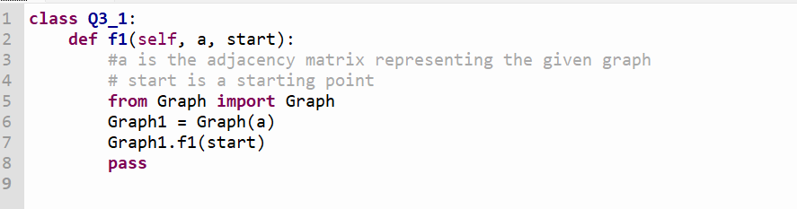

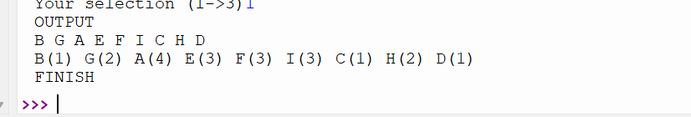

**Q3.2**

**Supposed the given graph has Euler's cycle. Apply the pseudocode in the**

**Graph.java file to write statements to find the Euler's cycle from the vertex 1 (B).**

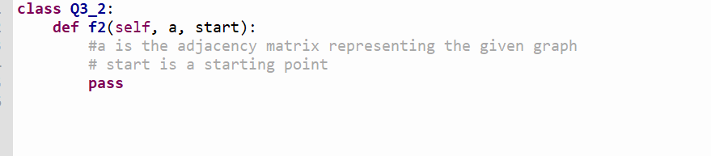

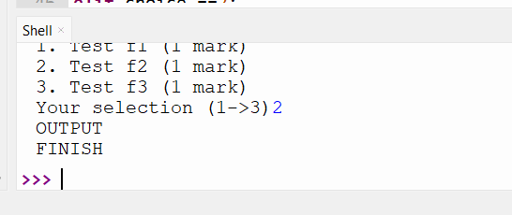

**Q3.3**

**Apply the Dijkstra’s shortest path algorithm to find the shortest path**

**from the vertex 0 (A) to the vertex 4 (E). (Note that in the weighted matrix, the value 999 is**

**considered as infinity).**

**The first line contains the list order of vertices in**

**the shortest path. The second line contains shortest distances to the vertices in the first line**

**respectively.**

